# Introduction

A financial center, or a financial hub, refers to a city with a strategic location, leading financial institutions, reputed stock exchanges, a dense concentration of public and private banks and trading and insurance companies. In addition, these hubs are equipped with first-class infrastructure, communications, and commercial systems, and there is a transparent and sound legal and regulatory regime backed by a stable political system. Such cities are favorable destinations for professionals because of the high living standards they offer along with immense growth opportunities.

Since the middle ages, London has been one of the most prominent trade and business centers. The city is one of the most visited places on earth and is among the most preferred places to do business.

From a business perspective, Singapore's attractiveness lies in its transparent and sound legal framework complementing its economic and political stability. The small island located in the Southeast Asia region has emerged as one of the Four Asian Tigers and established itself as a major financial center.

These two cities belong to different continent. One to Europe and the second to Asia. In our study we will compare neighborhood of both cities and tell how similar or dissimilar they are.

# Data

To Accomplish this study, we will use foursquare location to get all venues of each city. We will categorize venue on each city to see how theses city are similar or dissimilar. We will need:

* London’s geolocation,
* Singapore geolocation,
* Foursquare venues of each city. Each venue will be categorized and shown in a map.
* Venue name, description and category

We will take the most frequent venue category in each scity such as restaurant, park, coffee, shopping.

We will filter our neighborhood data frame to theses category venue and show in a map each category with a different color using folium.

# Methodology

After creating a foursquare account and getting our credentials we have to get London center geolocation and Singapore center geolocation. We will put this in two dictionaries with other information like area.

|  |  |  |  |
| --- | --- | --- | --- |
| City | Latitude | Longitude | Area |
| London | 51.509865 | -0.118092 | 1572 |
| Singapore | 1.290270 | 103.851959 | 721.5 |

The second step is to get neighborhood for each city using foursquare APIs. The result we be convert as a data frame showing all venues information’s for each city.

London data

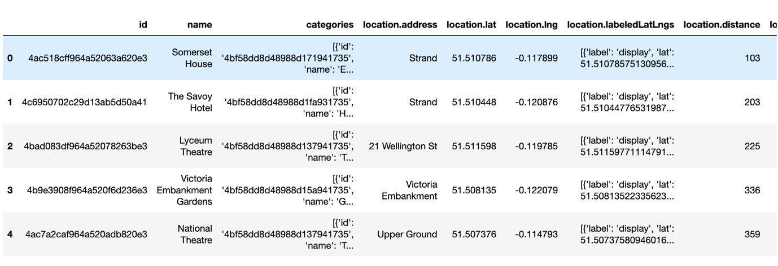

Singapore data

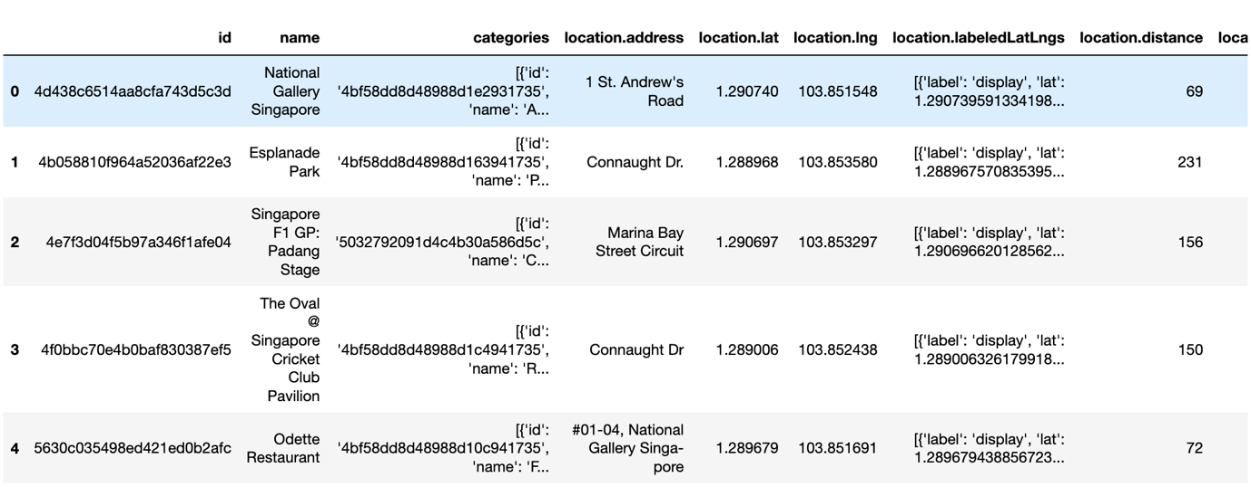

This figure shows the shape of each data frame

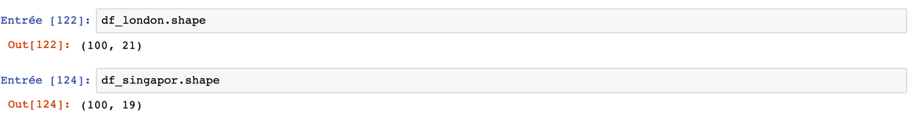

## Data cleaning

It’s important to clean our data as we want only to get the name, latitude, longitude and category of each data frame.

We see categories is an array with many values or we just want to display the category name of each place.

After applying a filter, we will get this result:

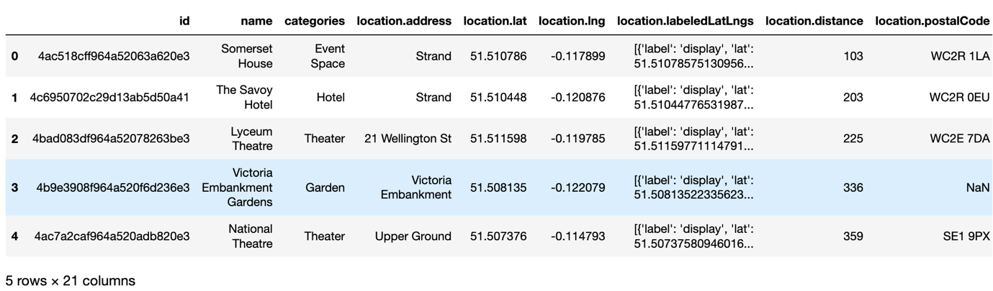

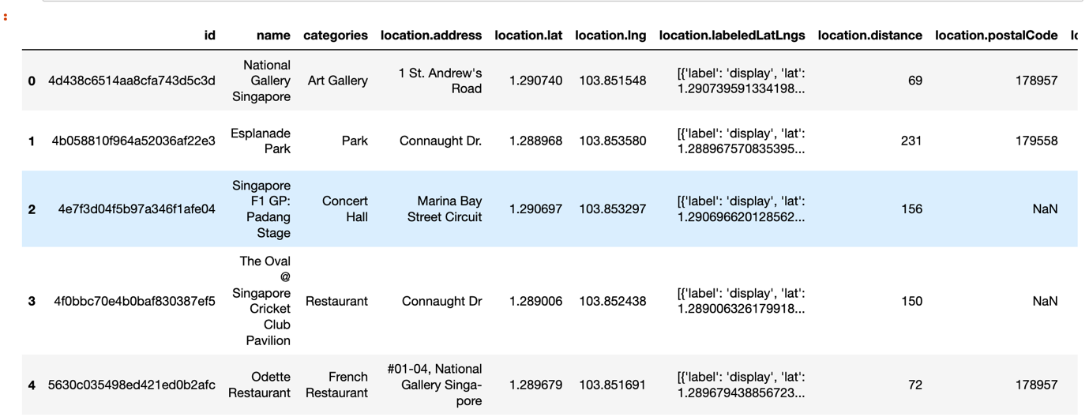

As you can see in the figure above, we have an explicit category name that we can use to categorize ours places.

after having obtained the categories of our places we will use only columns that we need and remove others columns. These columns are name, categories, latitude and longitude. We will also rename location.lat to lat and location.lng to lng. In the same time, we will reduce our data for showing only categories that we have selected. These categories are: Restaurant, park, shopping center and coffee. So, the final result of our data frames will look like this:

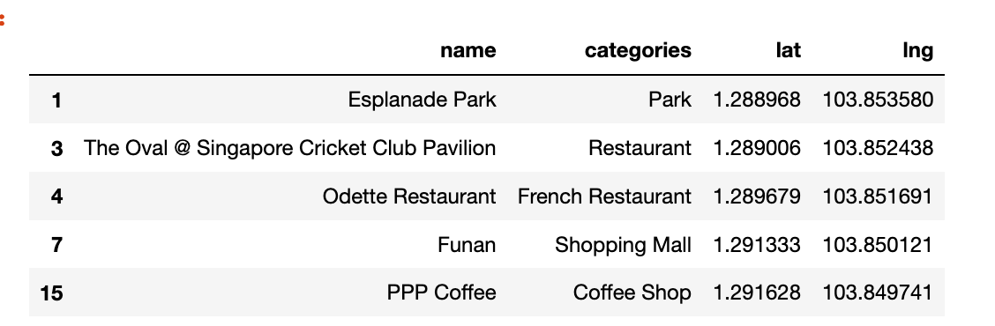

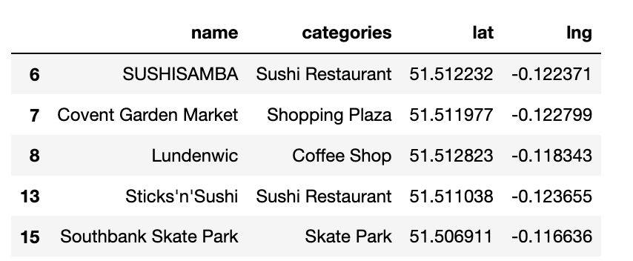

# Results

After cleaning our data, we can show the neighborhood of cities and a map using folium, before this we have to define a function which we will give a color for each place depending on these categories. The result of the two maps will be:

Green: restaurant

Blue: park

Pink: coffee

Red: shopping

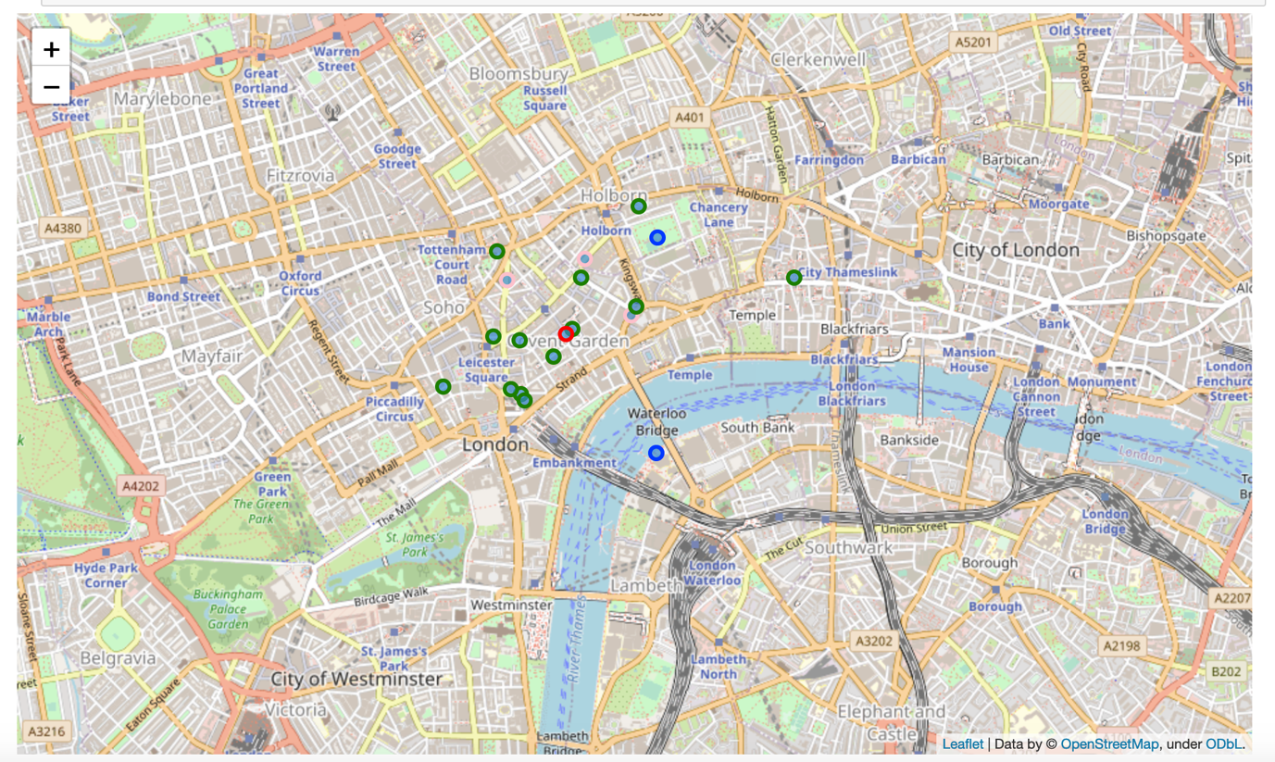

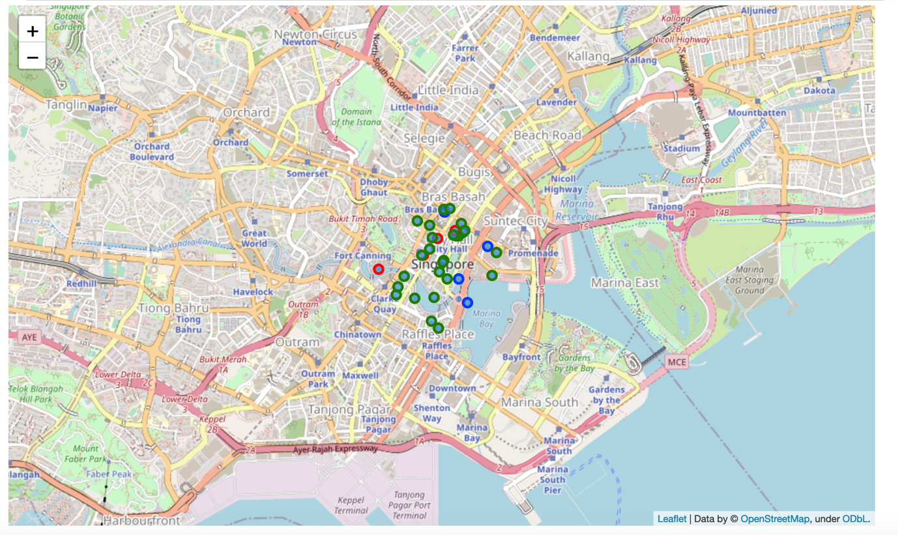

we can also print number of each place depending on his category:

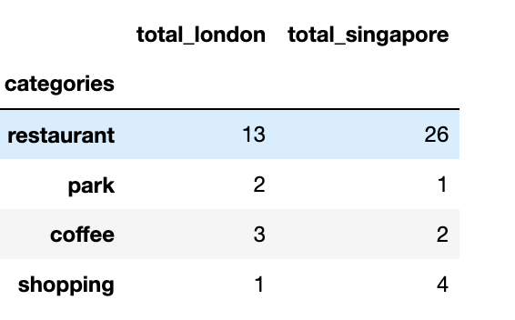

We can easily compare the two cities depending on category as seen in this graph

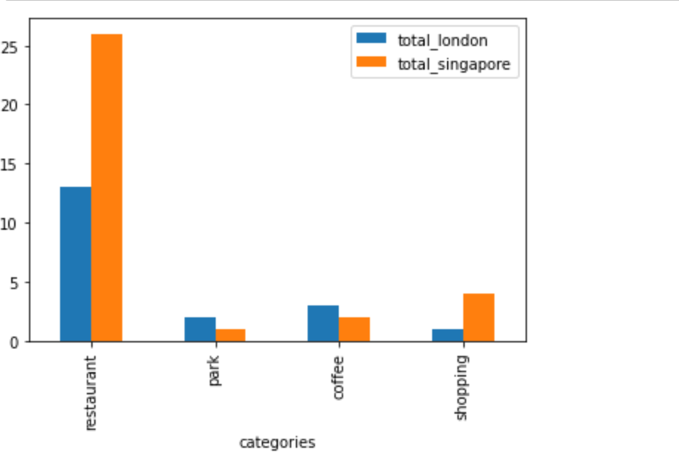

# Discussion

We can easily see that in London we have more restaurant and variety in the city. But in Singapore we have more shopping center and coffee shop than London. We can resume this result that Singapore is a best place for making shopping than London but for eating London is a good city. If someone want to open a restaurant, we can say that London is a good place.

# Conclusion

This report attempts to make a comparison of two big city using some king of categories. We can use more data to make a better comparison and also predict where is the place to make a business in food or in clothes. If someone want to start a business in these two cities in food or an clothes in these two cities this report can be a good start.